**Lambda Function**

**Lambda Function Syntax**

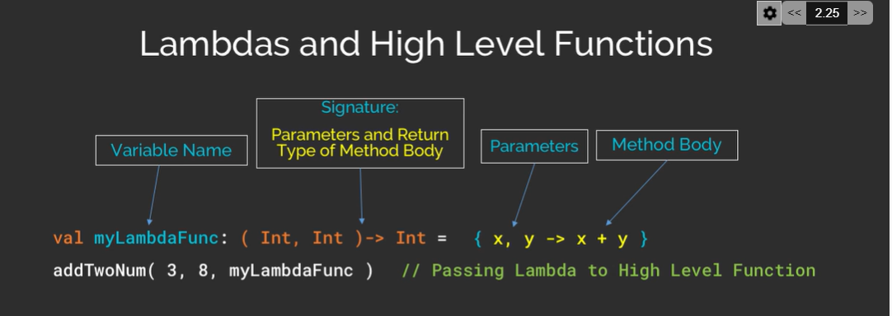

**Code Example**

**Example 1**

fun main() {  
 val lambdaFunction:(Int,Int)->Int=**{**x,y**->**x+y**}** *println*(lambdaFunction(10,20))  
}

**Example 2**

fun main() {  
 *println*(*credentials*("Vinay","Mandira"))  
}  
  
val *credentials*:(String,String)->String=**{**Fristname,Lastname**->** val passportname:String=Fristname+" "+Lastname;  
 passportname  
**}**

**Lambda Expression Can be Written in 2 ways**

1. With Type Annotation in Lambda Expression
2. Without Type Annotation in Lambda Expression

**With Type Annotation**

val *sum1* = **{** a: Int, b: Int **->** a + b **}**

**WithoutType Annotation**

val sum:(Int,Int)->Int=**{**a,b**->**a*b**}**

**Return Type in Lambda**